Rear door cable adjustment
1. Begin by removing the lower rear door panel.

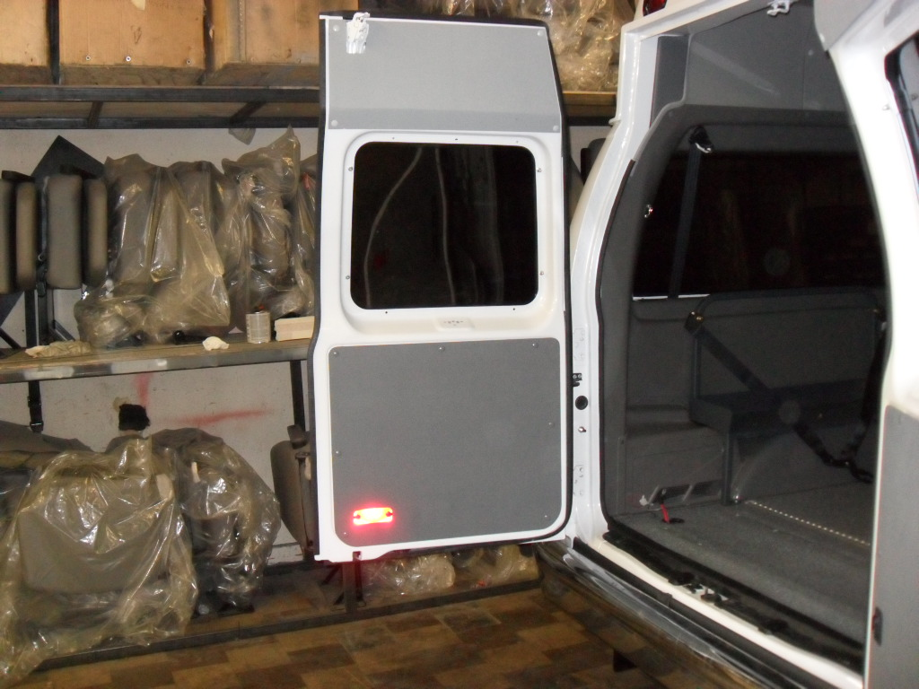

- Loosen the screw and nut 3/8” adjuster.
- Engage top latch by hand.
- Pull tension on cable until top latch opens.
- Slightly back tension off and retighten adjuster screw and nut (do not over tighten or cable will not function).
- Test door for function Open/close

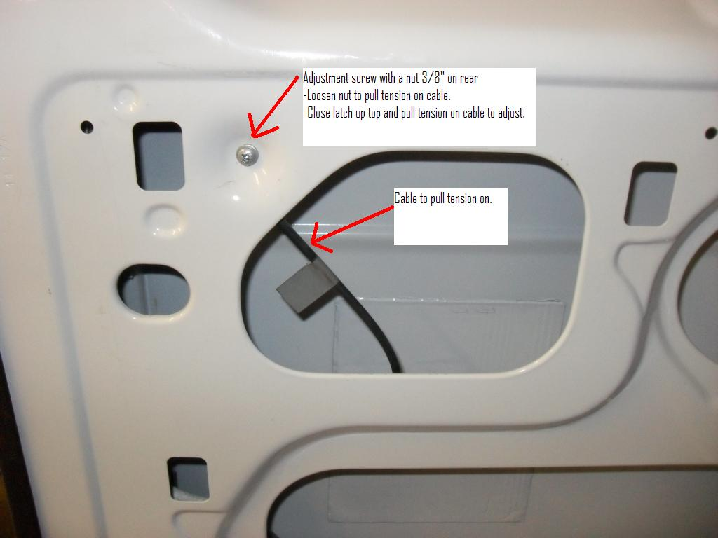

- Once door is properly adjusted install a zip tie and pull loose slack out of cable.
*Installing a zip tie will greatly reduce the chances of failure in the future.
8. Reinstall door panel.
